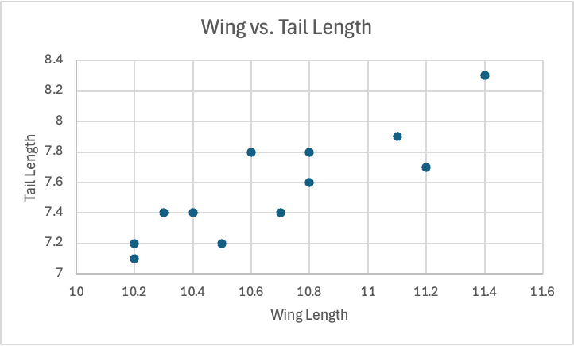

1. Sum of the product of differences: 1.323

Sum of x differences squared: 1.7167

Sum of y differences squared: 1.347

denominator: 1.52

Using formula: 0.87 for both R(X,Y) and R(Y,X)

1. The value should be considered significant at the p < 0.05 level if the computed p-value from the two-tailed test is below 0.05; otherwise, it is not significant.
2. Ho: r=0.75

r=.87

Z=1.08

p=.28, which is more than .05 so the correlation is not significant different from .75.